# **Curriculum Vitae**

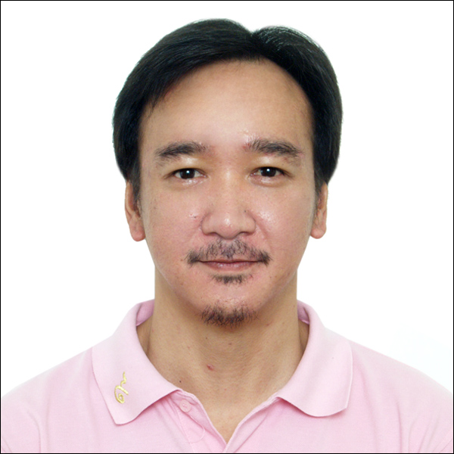

**Name:** Paitaya Puenpatom

**Date of Birth:** 9th September, 1975

**Address:** 16/1 Mu. 6 Bangpra, Sriracha

Cholburi, Thailand.

**Mobile:** +66 083-131-1851

**E-mail:** [paitaya@gmail.com](mailto:paitaya@gmail.com)

## EDUCATION

**University Webster University Thailand (Cha-Am campus)**

Media Communications and Public Relation

**Jan ’99 - March ’99 Dusit Thani College, Department of Hospitality**

Hotel Management and Marketing certified

**1995 - 1998 Colorado States University, Department of Designs**

BA - Basics of Graphics Designs

## High School Fountain Valley School, Colorado Springs, Co.

## Liberal Arts

## Elementary - Middle School Assumption Sriracha High School, Thailand

**Managing Editor/Localization/Transcreation**

**February 2013 - Present Managing Editor (Executive Manager) /Media Planner for Tashizan Digital Media (Japan) office in Thailand**

***Position: Key translator/interpreter and secretary***

***Key Responsibilities:***

* As Managing Editor, it was my duty to assess and monitor various departments within the company, optimize company productivity, set goals and evaluate company target
* Meet with clients and the art team to discuss the project direction and messages for online campaigns; responsible for content creation/localization/translation/transcreation of outgoing messages inline with client’s requirements and target market
* Assist in the creation, maintenance and monitoring of client websites, Facebook, Google+, Twitter, Youtube and Tumblr pages

***Achievements:***

Toshiba Smart City Facebook page administrator: worked closely with Toshiba (Japan) Co. Ltd. in localization of the Double Circle Facebook page to bring Toshiba vision of future smart city to life in an animation series. Managed the Thailand (Thai language) and Singapore (English language) Facebook pages.

<https://www.facebook.com/doublecircle.th?brand_redir=559204527449426>

Involved in Nike Running Japan campaign

<http://www.nike.com/jp/ja_jp/>

**February 2012 - February 2013 Contracted Assistant to Project Manager/Secretary/Translator for JICA (Japan International Cooperation Agency) during the Preparatory Survey on the Rehabilitation Project of the Outer Bangkok Ring Road (East Portion) in the Kingdom of Thailand (12 month contract)**

***Position: Key translator/interpreter and secretary***

***Key Responsibilities:***

* Translation of Government related documents, legal documents, reports and other relevant papers
* Conduct research, compile data regarding presentation
* Compose correspondence/reports, check deadlines on incoming requests and put preliminary work in play

***Achievements:***

I was one of the main translators involved in the project proposed by JICA in the mitigation efforts of one of the worst flooding in Thailand. I had a hand in helping compile all the necessary data and translate many important documents with regards to the engineering design projects, Government-to-Government correspondents, and the Master Plan of the Flood Management Plan of the Chao Phraya River Basin in the Kingdom of Thailand. My proudest moment was when the report was sent to His Majesty the King of Thailand.

**March 2008 - Present Freelance Localization and Transcreation and translation for PR Department of The Sofitel Central, Chidlom and Lionbridge Projects**

***Position: Freelance***

***Key Responsibilities:***

* Translations/localization/transceation/copywriting of press releases and other PR related print and digital media
* Translations/localization/transceation/copywriting of corporate product marketing, tag lines, copy texts and other media requirements to ensure best transitions from one country to another with regards to language barriers

***Achievements:***

Worked for the Central Department Store, one of the most successful entities in Thailand, as English translator on various PR projects. Copy write and localize texts for advertisements, campaigns and press releases.

Worked with Beats by Dr. Dre on promoting its new earphone, Powerbeats2 Wireless. Transceated and localized the ‘tag line’ and ‘copy text’ for the Thai market.

Worked closely with Caterpilar Incorporation on many localization projects of safety and operation manuals.

**September 2008 – Dec 2011 Media Insight Co., Ltd.**

***Position: Industry translator***

* Translate the Thai automobile industry news for Ford, Mazda, Nissan, GM and other automobile companies in Thailand
* Translations of other industry news: finance, local, and business news

**September 2003 - 2005 Hua Hin Today Newspaper**

***Position: Assistance to Editor (Executive Manager) / Layout specialist / Columnist***

**January 2005 - July 2008 Hua Hin Mirror Newspaper**

***Position: Managing Editor (Executive Manager) / Columnist***

***Key Responsibilities:***

* Involved in the running of the newspaper in almost all aspects; including, administrative works, bookkeeping, customer/partner relations, approving of artworks and article contents, and finding new partners and outlets
* Responsible for the design and layout of entire newspaper, including daily meetings and problem solving
* Implement policies and evaluate the company structure
* Wrote Thai and English news and features columns

***Achievements:***

Came to work with Hua Hin Today and was one of the founding members in helping the company expand a sister company, Hua Hin Mirror Newspaper.